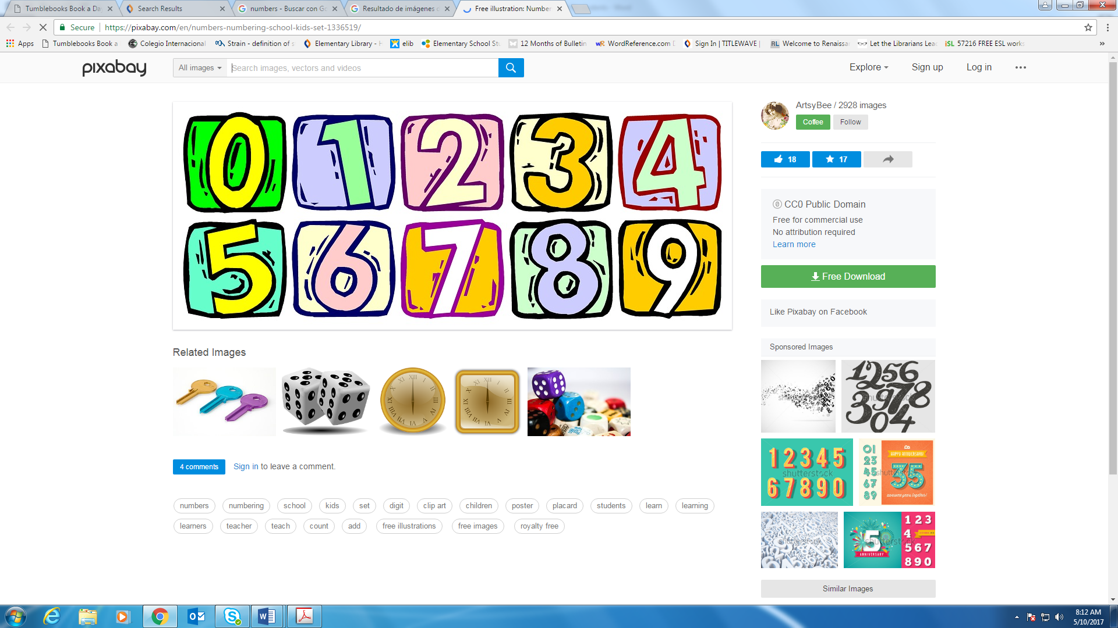 Recommended Reading for Students Entering 1st Grade

**Recommended Series**

Fly Guy

Green Light Readers

Llama Llama (Anna Dewdney)

My Sound Box (Jane Belk Moncure)

Clifford (Norman Bridwell)

Tadpoles

Pinkalicious (Victoria Kann)

Biscuit

**Authors**

Margaret Hillert

Dr. Seuss

Eric Carle

Mo Willems

Denise Fleming

Valeri Gorbachev

Bethany Roberts

Mem Fox

Jane Yolen

**Recommended Fiction Titles**

Brownie and Pearl

The Cat in the Hat

[The Pigeon Finds a Hot Dog!](http://www.arbookfind.com/bookdetail.aspx?q=134213&l=EN&slid=28688892)

Bear Feels Sick

Kitchen Dance

Happy Valentine's Day, Mouse!

Tortuga in Trouble

I Said, “Bed!”

Go, Dog, Go!

Rosie’s Walk

Pete the Cat

The Sky is Falling

Peppa Pig

I Went Walking

**Recommended Non-Fiction Titles/Authors**

Sounds Like Reading Series (Cleary, Brian P.)

From Caterpillar to Moth

Snails (Martha E.H. Rustad)

Transportation in Many Cultures (Rustad, Martha E. H.)

Rookie Series

**Note:** If you are checking books out from the CIC Elementary Library, PINK dot and some YELLOW dot books would be appropriate.

